# Problem Statement

## Title

"Improving Customer Profitability, Risk Management, and Digital Engagement through Transaction-Level Analysis in Bank”

## Context:

Bank operates across multiple cities in Spain, offering diverse financial products and services such as savings accounts, credit cards, loans, and digital banking platforms. Despite having robust transactional infrastructure, management has limited visibility into **customer behaviour trends, revenue leakage from fees, inefficient product recommendations, and digital adoption patterns**.

The bank aims to **leverage its historical transaction data (2023–2025)** to uncover **analytical patterns** that will:

* Improve customer engagement and retention
* Optimize product cross-selling strategies
* Strengthen risk mitigation approaches
* Enhance the overall efficiency of channel operations

## Business Challenge

1. **Unidentified Overleveraged Customers:**  
   Customers spending significantly more than their income may pose credit risks.
2. **Inefficient Product Recommendations:**  
   Many recommended financial products do not match the actual usage or interest of customers.
3. **Fee Revenue Distribution Is Unclear:**  
   The bank earns revenue from various fees (late payment, card, insurance), but branch-level and customer-segment-level contribution is unknown.
4. **Customer Loyalty and Retention Insights Are Lacking:**  
   There is no visibility into how long customers stay active or whether they are disengaging over time.
5. **Digital Transformation Monitoring Is Needed:**  
   The bank has been shifting toward digital channels but lacks analytics to verify behaviour changes and channel migration.
6. **Underused Cross-Sell Potential:**  
   The management suspects that many customers hold only one or two product types when they could be using more.

## Objective

The goal of this analysis is to create a **data-driven foundation** for:

* Detecting **at-risk or high-value customers**
* Improving **personalized financial offerings**
* Understanding **fee structures** and their contribution
* Analysing **channel behaviour shifts** to guide future investments in mobile and online banking
* Quantifying **customer lifecycle and engagement** for retention strategies

## Dataset Explanation

This dataset contains a **comprehensive record of 20,000 banking transactions** conducted by customers across various cities in Spain between **2023 and 2025**. Each row represents a **unique banking transaction**, capturing critical aspects of customer behaviour, product interaction, transactional activity, and revenue-generating elements such as fees and penalties.

The dataset was imported into a **MySQL database** under the schema bank, with the working table named bank_dataset.

## Purpose of Dataset

To enable in-depth **financial, behavioural, and operational analysis** of customers' banking activities. This includes:

* Understanding spending, saving, and borrowing habits
* Evaluating financial product usage and recommendations
* Tracking channel preferences (Branch, ATM, Mobile, Online)
* Identifying risk through late payments or high spending-to-income ratios
* Measuring branch-level and regional performance
* Analysing engagement through transaction frequency and tenure

|  |  |  |
| --- | --- | --- |
| Column Name | Type | Description |
| TransactionID | Integer | Unique identifier for each transaction (Primary Key) |
| CustomerID | Integer | Unique customer identifier |
| TransactionDate | DateTime | Timestamp of the transaction — used for time-based and cohort analysis |
| TransactionType | String | Nature of transaction: Deposit, Withdrawal, Card Payment, Loan Payment, etc. |
| Amount | Float | The monetary value of the transaction |
| ProductCategory | String | Main product type: Checking, Savings, Loan, Credit Card, Mortgage |
| ProductSubcategory | String | Further classification: Gold, Platinum, Student, etc. |
| BranchCity | String | City where the transaction occurred |
| BranchLat, BranchLong | Float | Latitude and longitude of the branch — used for geospatial insights |
| Channel | String | Mode of transaction: Online, Mobile, ATM, Branch |
| Currency | String | Currency of transaction (EUR or USD) |
| CreditCardFees | Float | Fees associated with credit card usage |
| InsuranceFees | Float | Insurance-related charges |
| LatePaymentAmount | Float | Penalties incurred due to late payments |
| CustomerScore | Integer | Internal scoring based on creditworthiness or engagement |
| MonthlyIncome | Float | Customer’s reported monthly income |
| CustomerSegment | String | Segment classification: High, Middle, Low Income |
| RecommendedOffer | String | The bank’s suggested financial product or benefit for the customer |

## Key Analytical Potentials

* Temporal Analysis: Via TransactionDate for seasonality, trends, and churn indicators
* Behavioral Clustering: Based on transaction types, frequency, and amounts
* Fee Revenue Attribution: Using CreditCardFees, InsuranceFees, and LatePaymentAmount
* Channel Analysis: To measure the shift toward digital banking
* Geospatial Intelligence: Leveraging BranchCity, BranchLat, and BranchLong
* Risk Profiling: Using CustomerScore, income-spending patterns, and payment delays
* Product Strategy: Assessing the alignment of RecommendedOffer with actual customer behavior

## Queries to Find Answer

### Query 1 Customer Lifetime Value and Engagement Pattern

**Purpose:** To identify the most valuable customers based on the total money transacted and engagement level (transaction count).  
**Business Use:** Helps the bank focus on top-tier clients for premium services, loyalty programs, and retention efforts.

use bank;

-- 1. Customer Lifetime Value and Engagement Pattern

SELECT

CustomerID,

SUM(Amount) AS TotalAmount,

COUNT(*) AS TransactionCount,

RANK() OVER (ORDER BY SUM(Amount)DESC) AS RankByValue

FROM

bank_dataset

GROUP BY CustomerID;

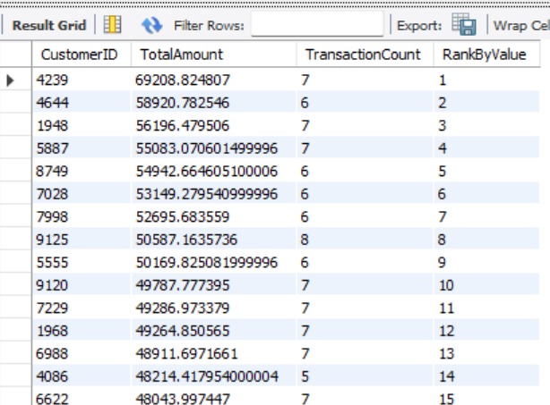

### Query 2: Monthly Trends and Seasonality

**Purpose:** To analyse the volume and value of transactions by type across months.  
**Business Use:** Understands seasonality in customer behaviour to plan campaigns (e.g., loan offers during high-spending months or card rewards in festive seasons).

-- 2. Monthly Trends and Seasonality

SELECT

DATE_FORMAT(TransactionDate, '%Y-%m') AS Month,

TransactionType,

COUNT(*) AS Transactions,

SUM(Amount) AS TotalAmount

FROM

bank_dataset

GROUP BY

Month, TransactionType

ORDER BY

Month,Transactions, TransactionType;

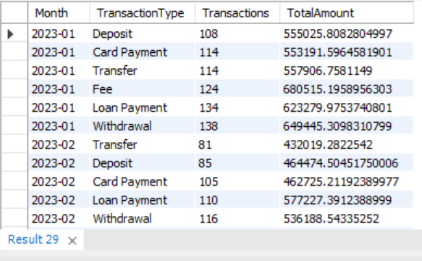

## Query 3: Risk Flags – High Fees and Late Payments

**Purpose:** Identifies customers frequently incurring late payment fees and evaluates their income levels.  
**Business Use:** Flags potential defaulters or financially stressed customers for risk assessment and credit policy tuning.

WITH RiskyLatePayers AS (

SELECT

CustomerID,

COUNT(*) AS LateFeeCount,

ROUND(SUM(LatePaymentAmount), 2) AS TotalLateFees,

ROUND(AVG(MonthlyIncome), 2) AS AvgIncome

FROM bank_dataset

WHERE LatePaymentAmount > 50

GROUP BY CustomerID

HAVING COUNT(*) > 2

)

SELECT *

FROM RiskyLatePayers

ORDER BY TotalLateFees DESC;

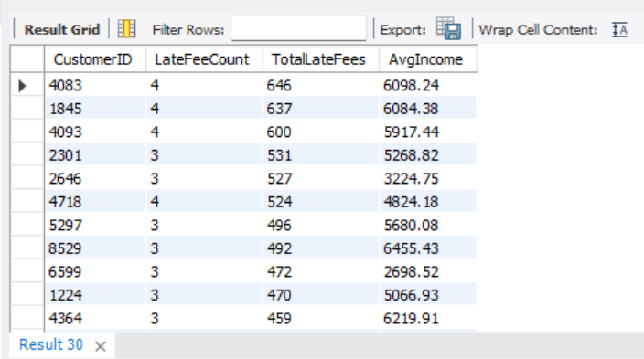

## Query 4: Channel Effectiveness and Customer Preference

**Purpose:** Breaks down transaction behavior across digital (Online, Mobile) vs physical (Branch, ATM) channels by customer segment.  
**Business Use:** Helps in optimizing branch operations, improving digital UX, and reducing operational costs by promoting digital adoption.

-- 4. Channel Effectiveness and Customer Preference

SELECT

CustomerSegment,

Channel,

COUNT(*) AS TotalTransactions,

SUM(Amount) AS TotalAmount

FROM

bank_dataset

GROUP BY

CustomerSegment, Channel

order by

CustomerSegment;

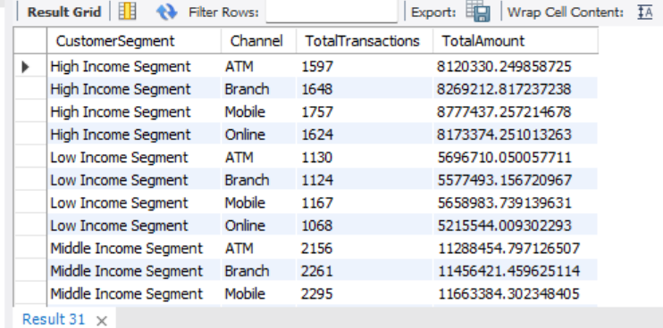

## Query 5: Recommendation System Effectiveness

**Purpose:** Evaluates whether recommended offers (like credit cards) are aligned with actual customer spending (card payments).  
**Business Use:** Assesses the accuracy of marketing and recommendation algorithms to improve personalized offers.

- 5. Recommendation System Effectiveness

SELECT

RecommendedOffer,

COUNT(*) AS OfferCount,

SUM(CASE WHEN TransactionType = 'Card Payment' THEN Amount ELSE 0 END) AS TotalCardPayments,

AVG(MonthlyIncome) AS AvgIncome

FROM

bank_dataset

GROUP BY

RecommendedOffer

ORDER BY

TotalCardPayments DESC;

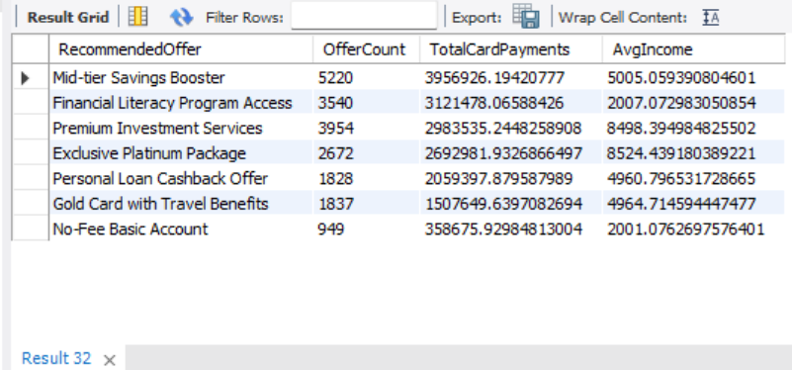

## Query 6: City-Level Profitability and Geographical Patterns

**Purpose:** Maps where transaction volumes and fee revenue are highest geographically.  
**Business Use:** Aids in regional performance assessment and helps decide where to expand or optimize branch operations.

-- 6. City-Level Profitability and Geographical Patterns

SELECT

BranchCity,

COUNT(*) AS TotalTransactions,

SUM(Amount) AS TotalTransactionAmount,

SUM(CreditCardFees + InsuranceFees + LatePaymentAmount) AS TotalFees

FROM

bank_dataset

GROUP BY BranchCity

ORDER BY TotalFees DESC;

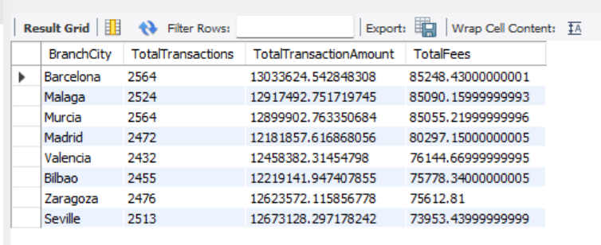

## Query 7: Customer Churn Signals

**Purpose:** Finds mismatches between the product customers use most and what they’re being offered.  
**Business Use:** Misaligned recommendations can frustrate customers and lead to churn. Helps refine targeting to improve customer satisfaction and retention.

-- 7. Customer Churn Signals

WITH ProductUsage AS (

SELECT

CustomerID,

ProductCategory,

COUNT(*) AS UsageCount,

RANK() OVER (PARTITION BY CustomerID ORDER BY COUNT(*) DESC) AS rnk

FROM bank_dataset

GROUP BY CustomerID, ProductCategory

),

TopProduct AS (

SELECT CustomerID, ProductCategory AS MostUsedProduct

FROM ProductUsage

WHERE rnk = 1

),

OfferMapped AS (

SELECT

CustomerID,

RecommendedOffer,

CASE

WHEN RecommendedOffer LIKE '%Savings%' THEN 'Savings Account'

WHEN RecommendedOffer LIKE '%Loan%' THEN 'Loan'

WHEN RecommendedOffer LIKE '%Card%' THEN 'Credit Card'

WHEN RecommendedOffer LIKE '%Investment%' THEN 'Savings Account'

WHEN RecommendedOffer LIKE '%Account%' THEN 'Checking Account'

ELSE 'Other'

END AS MappedProduct

FROM bank_dataset

),

Mismatch AS (

SELECT

t.CustomerID,

t.MostUsedProduct,

o.MappedProduct,

o.RecommendedOffer

FROM TopProduct t

JOIN OfferMapped o ON t.CustomerID = o.CustomerID

GROUP BY t.CustomerID, t.MostUsedProduct, o.MappedProduct, o.RecommendedOffer

HAVING t.MostUsedProduct != o.MappedProduct

)

SELECT * FROM Mismatch;

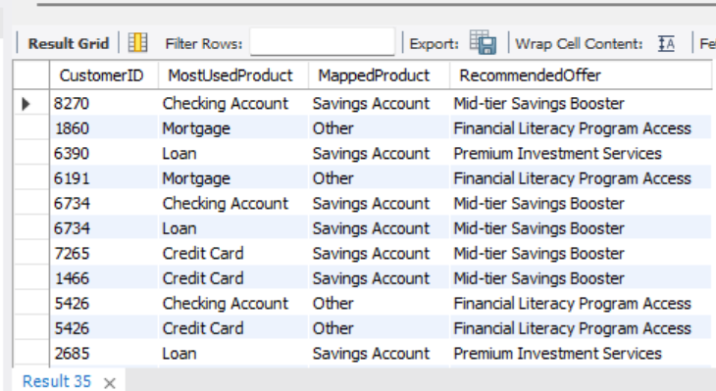

## Query 8: Currency and FX Exposure Analysis

**Purpose:** Shows the volume of foreign currency transactions by product category.  
**Business Use:** Informs FX risk management and helps design tailored products for high-value FX clients (e.g., international credit cards, forex savings).

-- 8. Currency and FX Exposure Analysis

SELECT

Currency,

ProductCategory,

COUNT(*) AS TransactionCount,

SUM(Amount) AS TotalAmount

FROM

bank_dataset

GROUP BY Currency, ProductCategory

order by ProductCategory;

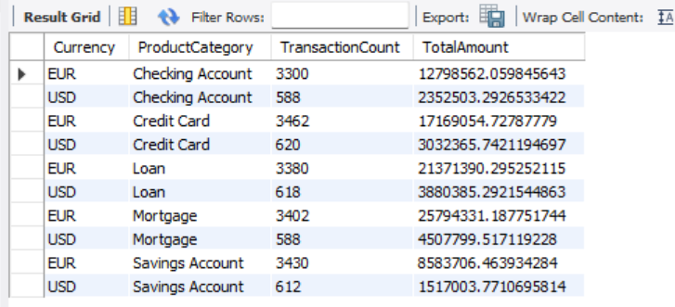

## Query 9: Product Category Profitability

**Purpose:** Breaks down how much fee revenue each product and subcategory contributes.  
**Business Use:** Identifies high-margin products (like premium cards or loans) to guide marketing, cross-selling, and product development.

-- 9. Product Category Profitability

SELECT

ProductCategory,

ProductSubcategory,

SUM(CreditCardFees + InsuranceFees + LatePaymentAmount) AS TotalFees

FROM

bank_dataset

GROUP BY

ProductCategory, ProductSubcategory

ORDER BY

TotalFees DESC;

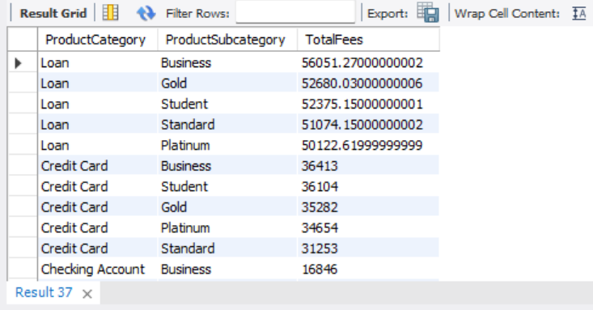

## Query 10: Detect Income vs Spending Mismatch (Potential Over-Leverage)

**Purpose:** Detects customers spending more than double their income regularly.  
**Business Use:** Useful for credit risk teams to monitor over-leveraged clients and prevent loan defaults.

-- Query 10: Detect Income vs Spending Mismatch (Potential Over-Leverage)

WITH Spending AS (

SELECT

CustomerID,

ROUND(SUM(CASE WHEN TransactionType IN ('Card Payment', 'Withdrawal', 'Transfer', 'Loan Payment') THEN Amount ELSE 0 END), 2) AS TotalSpending,

ROUND(AVG(MonthlyIncome), 2) AS AvgIncome

FROM bank_dataset

GROUP BY CustomerID

)

SELECT *,

ROUND(TotalSpending / AvgIncome, 2) AS SpendToIncomeRatio

FROM Spending

WHERE TotalSpending > AvgIncome * 2

ORDER BY SpendToIncomeRatio DESC;

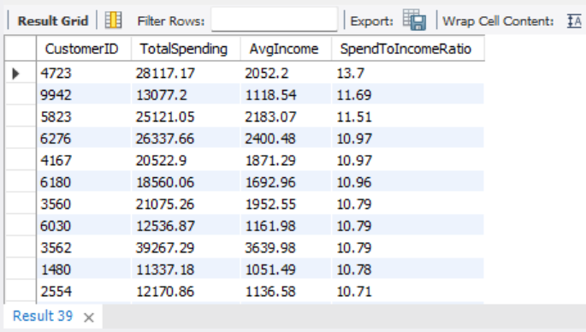

## Query 11: Geographical Trends in Fee Revenue

**Purpose:** Calculates how much each city contributes to total bank fee revenue.  
**Business Use:** Pinpoints locations with high profitability potential and helps prioritize local market strategies.

-- Query 11: Geographical Trends in Fee Revenue

WITH CityFees AS (

SELECT

BranchCity,

ROUND(SUM(CreditCardFees + InsuranceFees + LatePaymentAmount), 2) AS TotalFees

FROM bank_dataset

GROUP BY BranchCity

),

TotalBankFees AS (

SELECT ROUND(SUM(CreditCardFees + InsuranceFees + LatePaymentAmount), 2) AS BankTotalFees

FROM bank_dataset

)

SELECT

c.BranchCity,

c.TotalFees,

CONCAT(ROUND(c.TotalFees / t.BankTotalFees * 100, 2), '%') AS FeeContribution

FROM CityFees c, TotalBankFees t

ORDER BY TotalFees DESC;

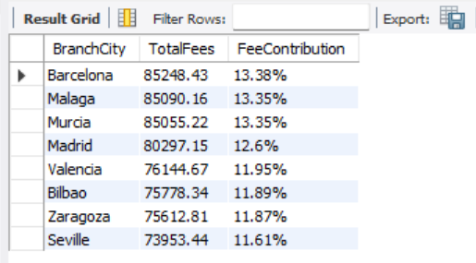

## Query 12: Customer Retention Proxy (Months Active)

**Purpose:** Measures the customer’s lifespan in the system based on first and last transactions.  
**Business Use:** Acts as a proxy for retention and helps identify inactive or dormant accounts needing reactivation campaigns.

-- Query 12: Customer Retention Proxy (Months Active)

WITH CustomerActivity AS (

SELECT

CustomerID,

MIN(DATE(TransactionDate)) AS FirstTxn,

MAX(DATE(TransactionDate)) AS LastTxn

FROM bank_dataset

GROUP BY CustomerID

)

SELECT

CustomerID,

FirstTxn,

LastTxn,

TIMESTAMPDIFF(MONTH, FirstTxn, LastTxn) AS MonthsActive

FROM CustomerActivity

ORDER BY MonthsActive DESC;

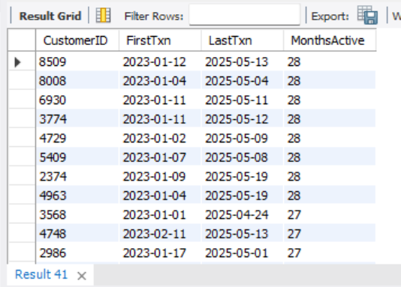

## Query 14: Product Cross-Sell Score

**Purpose:** Counts how many distinct product categories each customer uses.  
**Business Use:** Aids in segmenting multi-product customers (more loyal) and identifying cross-sell opportunities (e.g., upselling insurance to savings users)

-- Query 14: Product Cross-Sell Score

WITH ProductCounts AS (

SELECT CustomerID, COUNT(DISTINCT ProductCategory) AS UniqueProducts

FROM bank_dataset

GROUP BY CustomerID

)

SELECT *

FROM ProductCounts

WHERE UniqueProducts >= 3

ORDER BY UniqueProducts DESC;

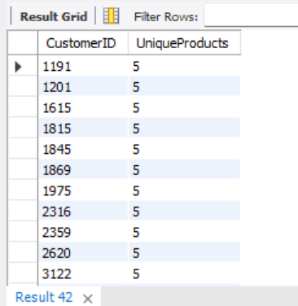

## Query 15: First vs Last Channel Usage (Shift to Digital?)

**Purpose:** Tracks if a customer has shifted from physical to digital channels over time.  
**Business Use:** Measures digital transformation progress and helps evaluate the success of mobile/online banking adoption initiatives

-- Query 15: First vs Last Channel Usage (Shift to Digital?)

WITH RankedTxn AS (

SELECT

CustomerID,

Channel,

TransactionDate,

ROW_NUMBER() OVER (PARTITION BY CustomerID ORDER BY TransactionDate ASC) AS FirstUse,

ROW_NUMBER() OVER (PARTITION BY CustomerID ORDER BY TransactionDate DESC) AS LastUse

FROM bank_dataset

),

FirstLast AS (

SELECT

CustomerID,

MAX(CASE WHEN FirstUse = 1 THEN Channel END) AS FirstChannel,

MAX(CASE WHEN LastUse = 1 THEN Channel END) AS LastChannel

FROM RankedTxn

GROUP BY CustomerID

)

SELECT *

FROM FirstLast

WHERE FirstChannel != LastChannel;

